Ideation Phase
Define the Problem Statements

Date | 08 October 2026
Team ID | 9100SmartGirls
Project Name | Streamlining IT Procurement: Automating Standard Laptop Orders with Flow Designer
Maximum Marks | 2 Marks

Customer Problem Statement Template:
Create a problem statement to understand your customer's point of view. The Customer Problem Statement template helps you focus on what matters to create experiences people will love.
A well-articulated customer problem statement allows you and your team to find the ideal solution for the challenges your customers face. Throughout the process, you’ll also be able to empathize with your customers, which helps you better understand how they perceive your product or service.

Reference: https://miro.com/templates/customer-problem-statement/
Example:
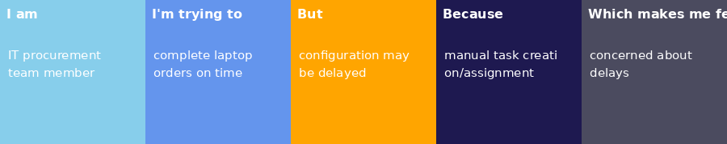
Problem Statement (PS) | I am (Customer) | I’m trying to | But | Because | Which makes me feel
PS-1 | IT procurement team member | Ensure standard laptop orders move through approval and configuration on time. | The configuration task can be missed or delayed after the order is placed. | Much of the process is manual and the required configuration task is not automatically created and assigned. | Concerned about delays, extra manual work, and possible mistakes.
PS-2 | Employee requesting a standard laptop | Receive a configured laptop without unnecessary waiting. | Laptop configuration may be delayed before the device is given to the user. | The manual process can miss or delay the configuration step. | Frustrated or uncertain because the laptop may take longer to become ready.

